**Battle of the Neighborhoods in Saint Louis**

Kalpana Joshi

August 26th 2020

1. Introduction
   1. Background
   2. Problem
   3. Interested Parties
2. Data Acquisition
   1. Data Sources
   2. Data Transformation
3. Methodology
   1. Exploratory data analysis
   2. Machine learnings used and why
4. Results
5. Discussion
   1. Observations
   2. Recommendations
6. Conclusion
7. **Introduction**

**1.a Background**

Saint Louis is a quiet city in Missouri, right in the heart of the United States of America. Its widely known for its very popular baseball team, the Cardinals, which attracts a lot of tourists during the game season. The city has several natural places to visit during summer time like lakes, adventure trails and parks. There are many facilities provided to the public free of cost like the Saint Louis Zoo, Art Museum, History Museum and the Science Centre. Along with these free avenues there are several malls, restaurants, eateries which provide the residents a plethora of activities to keep themselves busy during weekends or holidays. In this project we will be exploring the various Neighborhoods in the city of Saint Louis and the popular venues in each of these.

**1.b Problem**

The project aims to explore the venues in the different parts of Saint Louis and determine the most popular ones in a certain area. This analysis is aimed at finding out the best suited locations to start up a new business like a restaurant or a clothing store.

**1.c Interested Parties**

The result of this project will benefit many of the entrepreneurs in Saint Louis to determine the location that is best for them to set up shop. Since we will be assessing the popular venues in various locations, we will get an idea of the kind of customers and their purpose while visiting these locations. This will increase the chances of them visiting the stores of these entrepreneurs if they set up their business accordingly.

1. **Data Acquisition**

**2.a Data Sources**

The data for this project has been accessed from the website: <https://public.opendatasoft.com/explore/dataset/us-zip-code-latitude-and-longitude/table/> , which has a detailed list of all the zip codes of the US cities along with other information such as City, State, Longitude, Latitude, Time Zone, Daylight savings time flag and Geopoint. This data can be filtered by State. Below is a snapshot of the data filtered for the State of Missouri where Saint Louis is located:

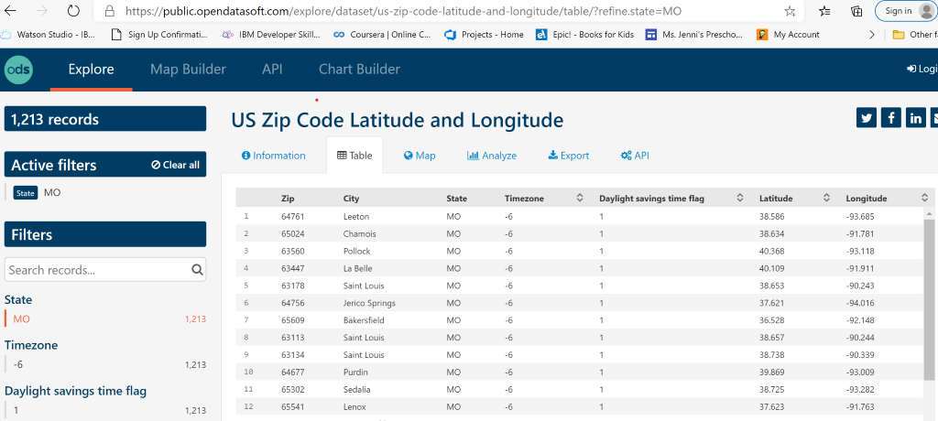

Above data can be exported in the csv format and then read into a pandas Dataframe.

We will also be utilizing the Foursquare API to determine the venues at each of these locations. Below is a screenshot of the information received from Foursquare for a specific location. The highlighted portions are the ones we will be focusing on during our analysis.

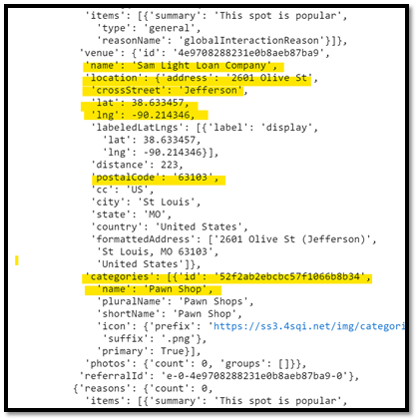

**2.b Data Cleaning**

The data extracted from the website below is in the csv format.

<https://public.opendatasoft.com/explore/dataset/us-zip-code-latitude-and-longitude/table/>

Fist we need to create a Dataframe with the data in the above file. This data is at the state level, so we need to filter it further by city (Saint Louis).

**2.c Feature Selection**:

We can further drop fields which will not be used during our analysis like ‘Time zone’, ‘Daylight Saving time flag’ and ‘Geopoint’. The final Dataframe had about 71 samples or information about 71 Postal Codes in the city of Saint Louis with their respective Latitudes and Longitudes.

1. **Methodology**

**3.a Exploratory data analysis:**

The dataframe created from the csv file needs to be cleaned in order to move forward with our analysis. So, we first need to filter it by city of Saint Louis. For feature selection, certain columns or fields were dropped such as Time zone, Daylight saving time flag and geopoint. Both these steps are depicted in the screenshots below.

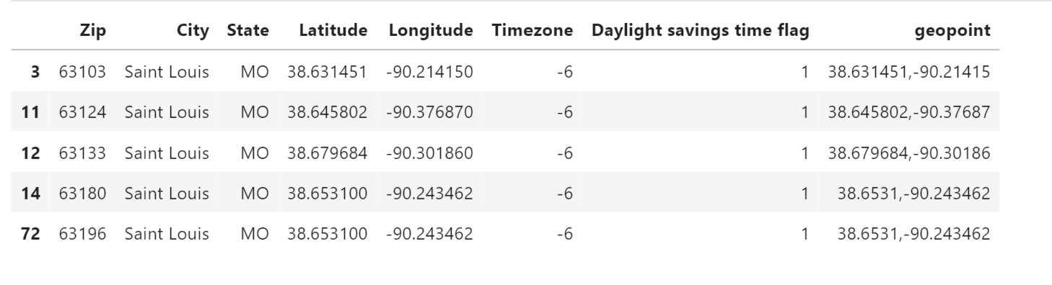

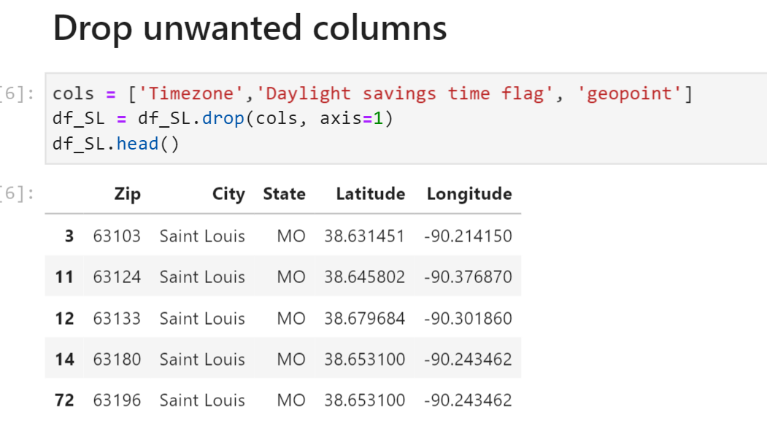

Visualizing the City of Saint Louis on the Map with all the zip codes highlighted:

We can visualize the city of Saint Louis by first finding the coordinates of the city (Latitude: 38.6268039, Longitude: -90.1994097) and then plotting all the Zip codes that are present in our database. Later we will be diving these Zip codes into clusters based on the types of venues.

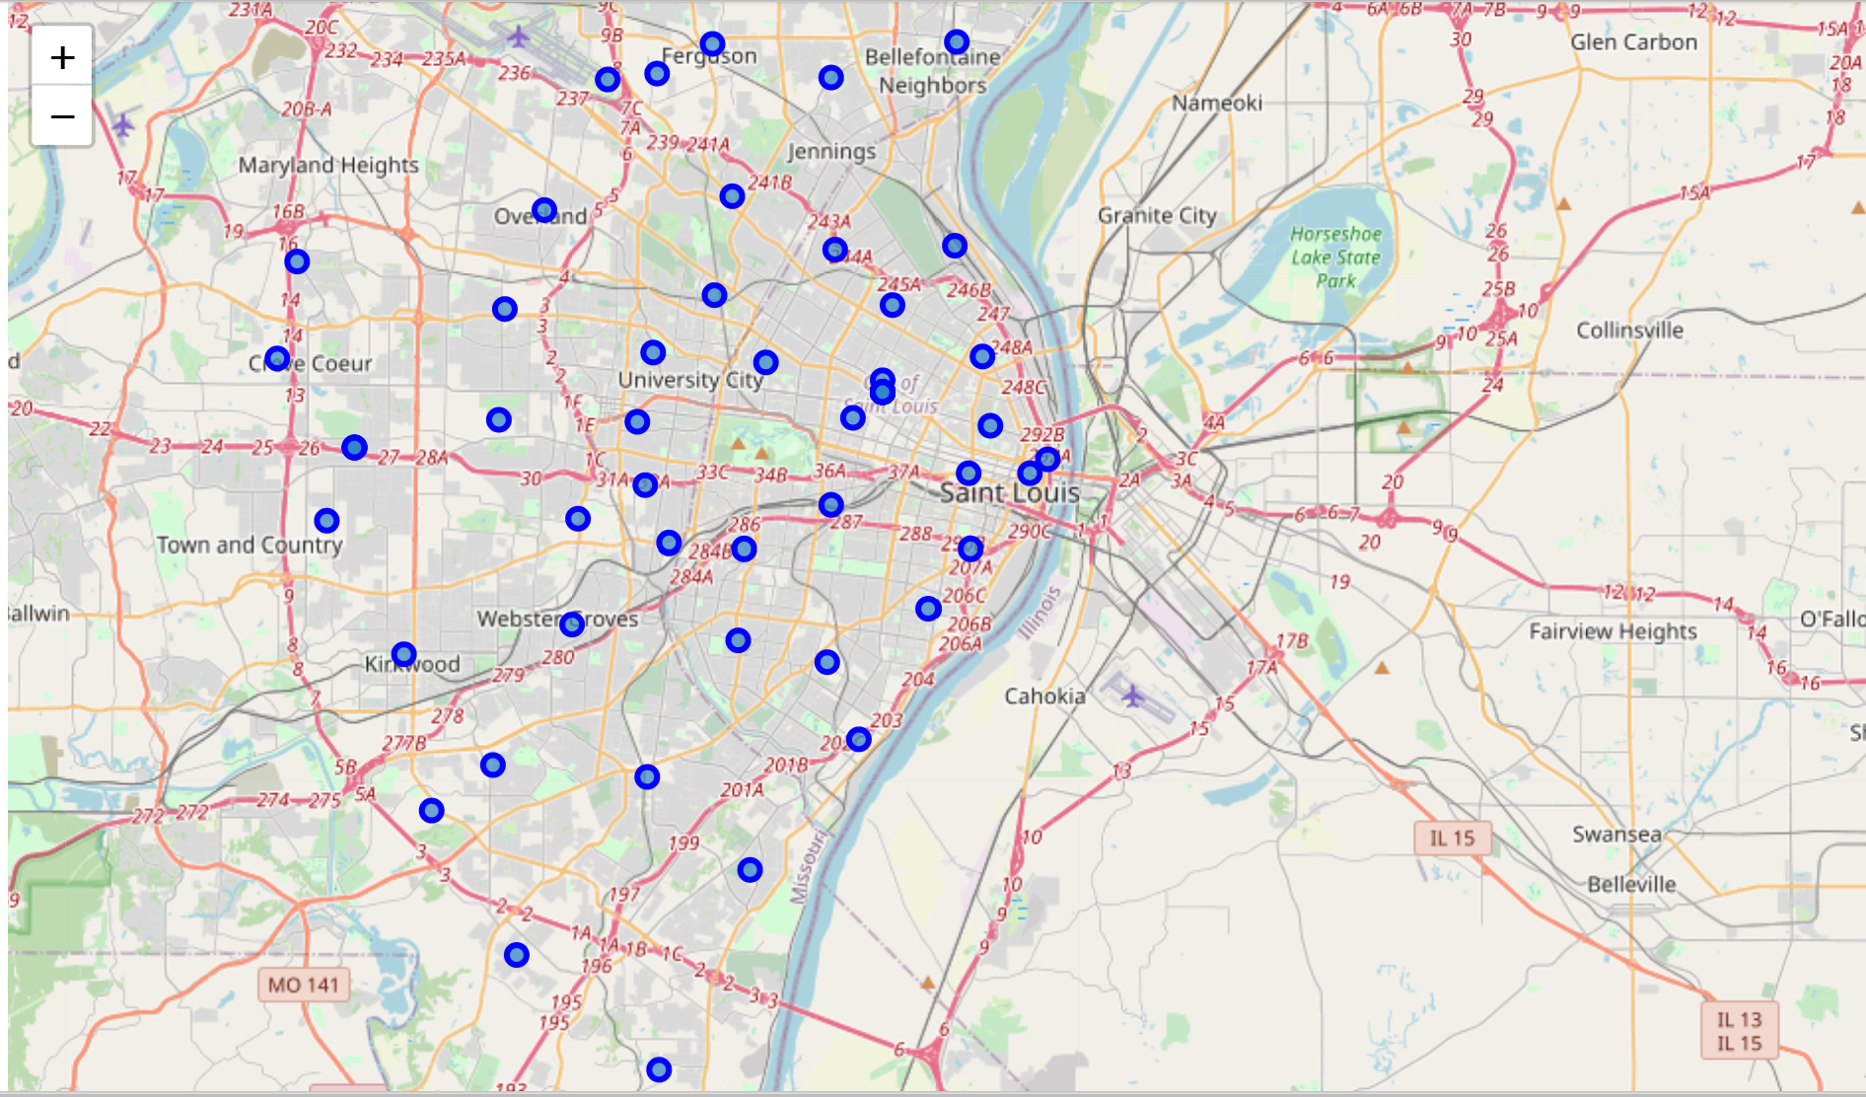

Make API calls to get all the possible venues in the surroundings of the first Zip:

Now, we can begin our exploration by analyzing the very first Zip code (63178 with coordinates: 38.6531, -90.243462) by making an API call to Foursquare. The result obtained in the screenshot shown below. The details which we need to focus on are Venue Name, Venue Category, Postal Code, Latitude and Longitude. We can see in the example below that the first venue in the list is ‘Sam Light Loan Company’ which is a ‘Pawn Shop’.

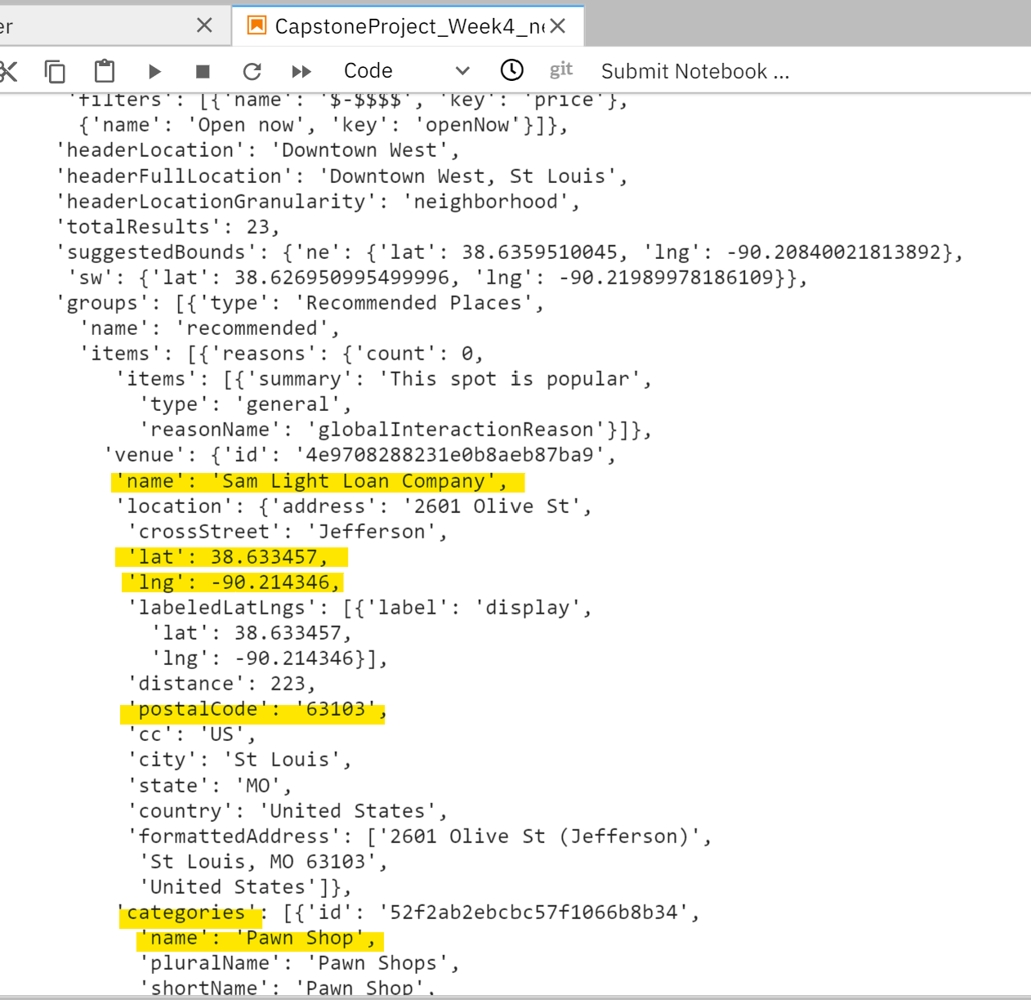

We will now find out the details about all the other venues around the first Zip Code and then arrange them in a dataframe like below.

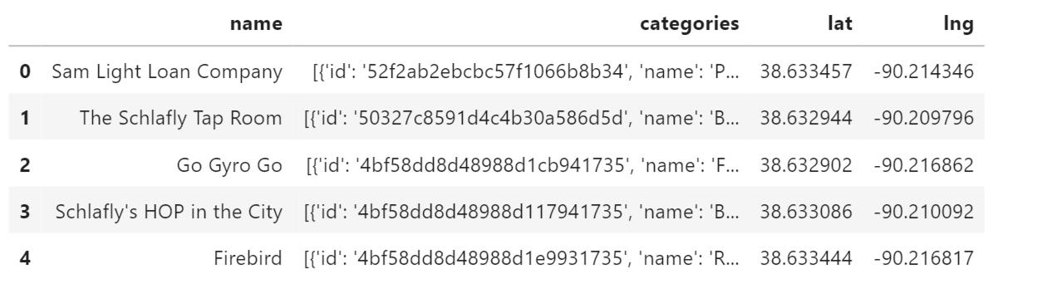

Here we can find the venue names and categories very clearly which will help us in determining the types of businesses in each area. Therefore, we will now create a dataframe with all the venue names, categories and coordinates for all the zip codes in the city of Saint Louis:

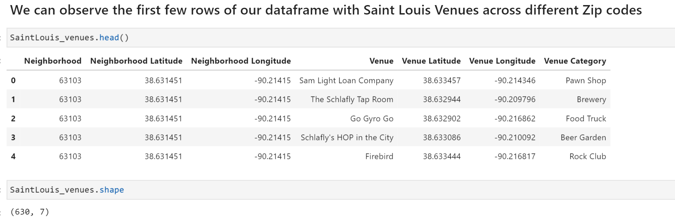

We can see that there is a total of 630 venues across different Zip codes out of which 169 are unique values. Following table shows the number of venues across each zip code:

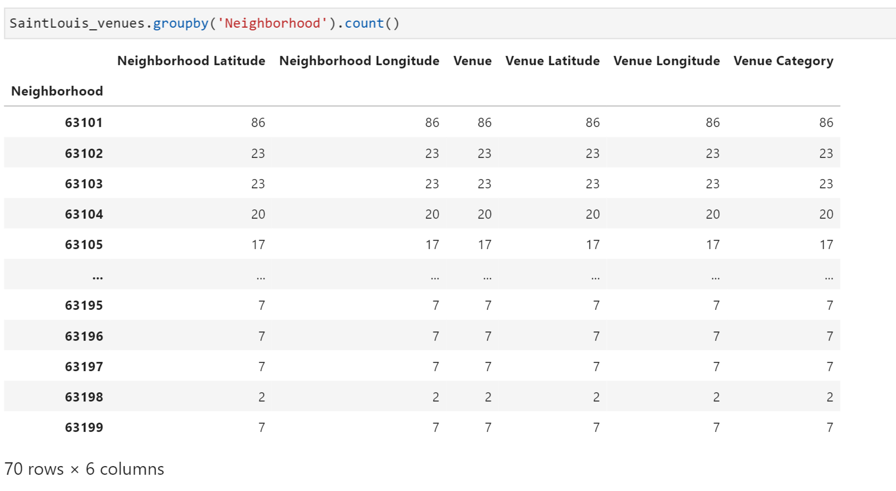

For further analysis, we normalize our data by performing ‘One-hot coding’ (by creating new columns for all 164 venues across all the Zip codes and assigning dummy values according to their presence in the location)

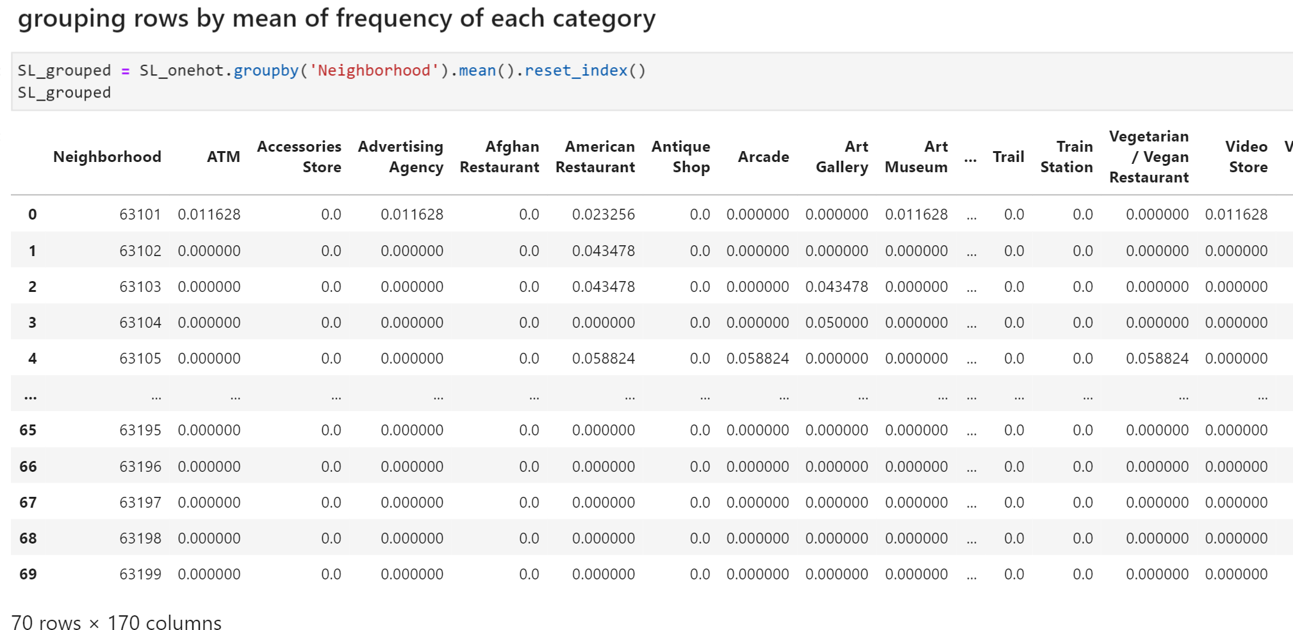

Now we can analyze the top 5 venues for each of the locations:

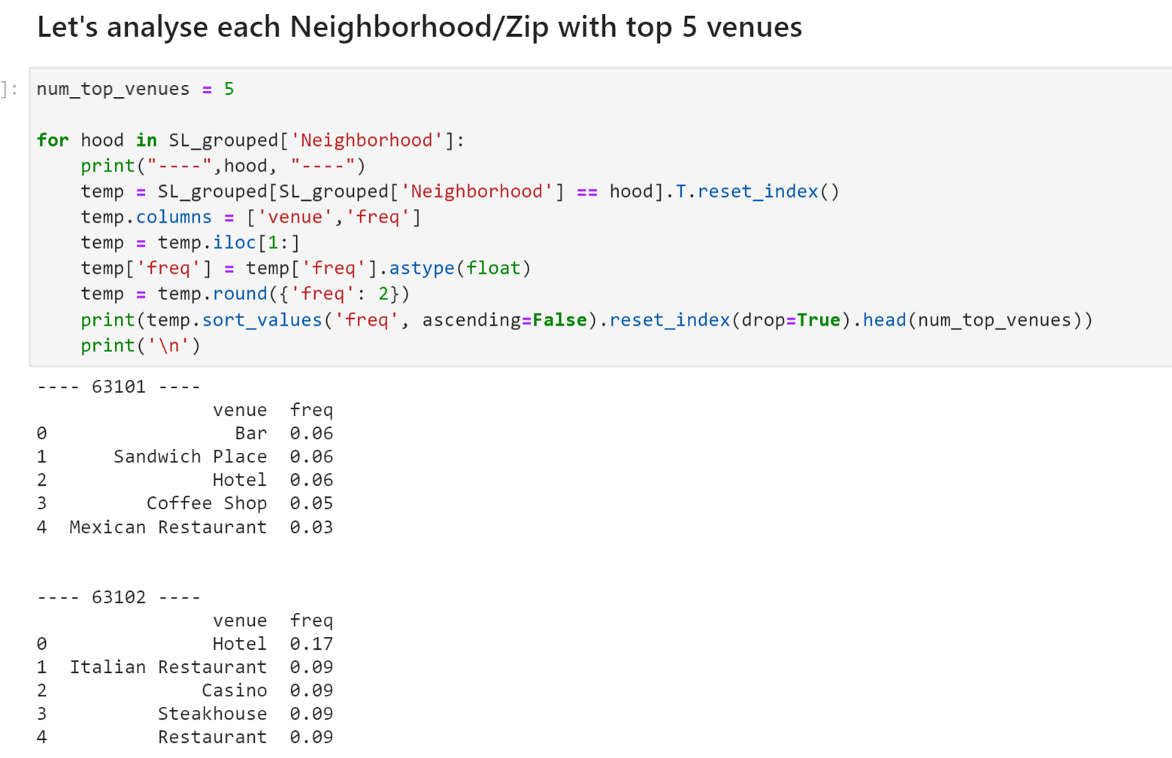

Following is the dataframe with the Top 10 venues across each Zip code:

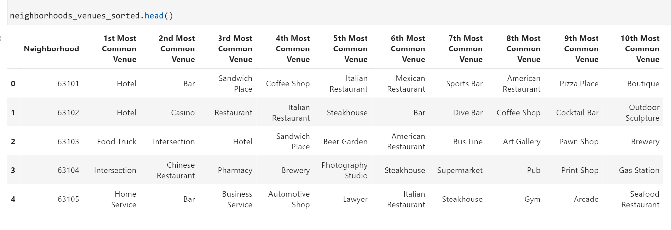

**3.b Machine Learning usage:**

Now, we can use the KMeans Clustering methodology to segregate the zip codes into clusters based on their venue categories as follows. We initialize our clusters to 5 for this analysis:

Reason for using KMean Clustering:

KMeans Clustering is a machine learning methodology that can be used for both supervised and unsupervised learning. In our example, we do not have the clusters defined to begin with. Therefore, we need to train our model using the unsupervised method for which KMeans is the most appropriate. We begin with a set number of clusters (i.e. 5) and start creating our model based on the available data around the venue categories across each zip code. The model looks for the zip codes with similar patterns in the top 10 venue categories and groups them together.

1. **Results**

We use the KMeans clustering method define above to find out the labels for each of the Zip codes in the final dataframe with Top 10 venues

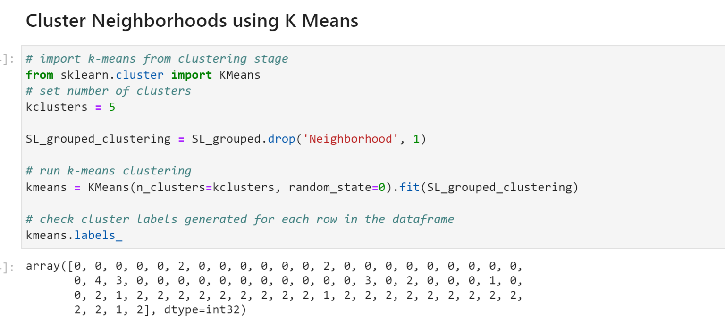

Assign these labels to the Neighborhoods with Top 10 venues:

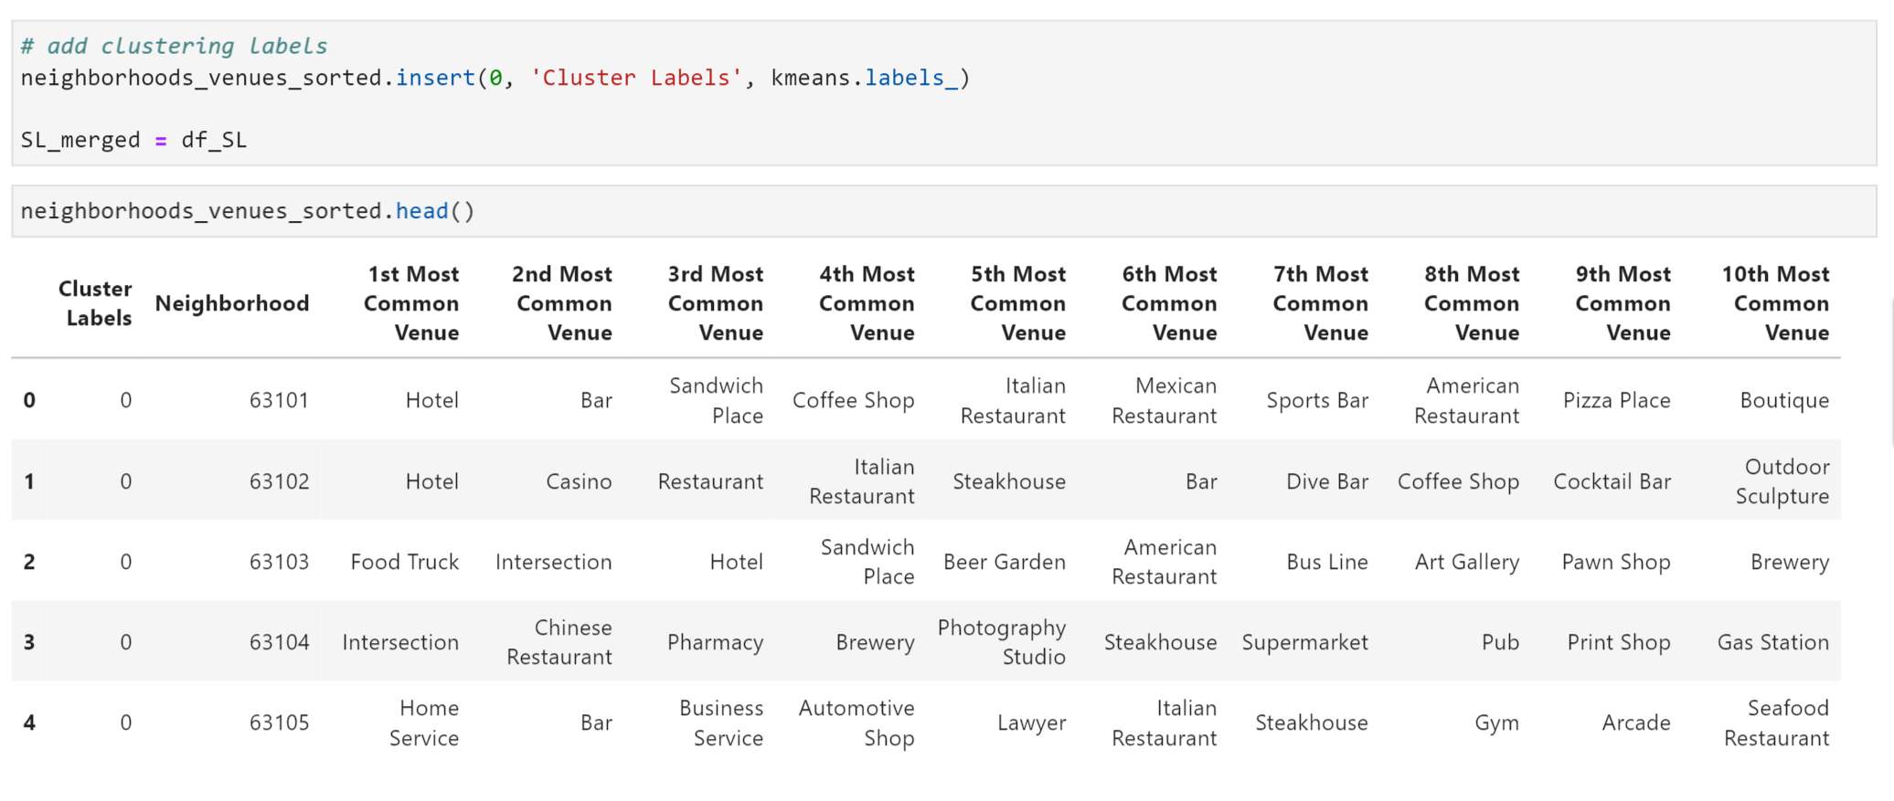

Now, merge this dataframe with the original dataframe of Saint Louis city to get a detailed picture with the Zip Code, City name, State, Longitude, Latitude as follows:

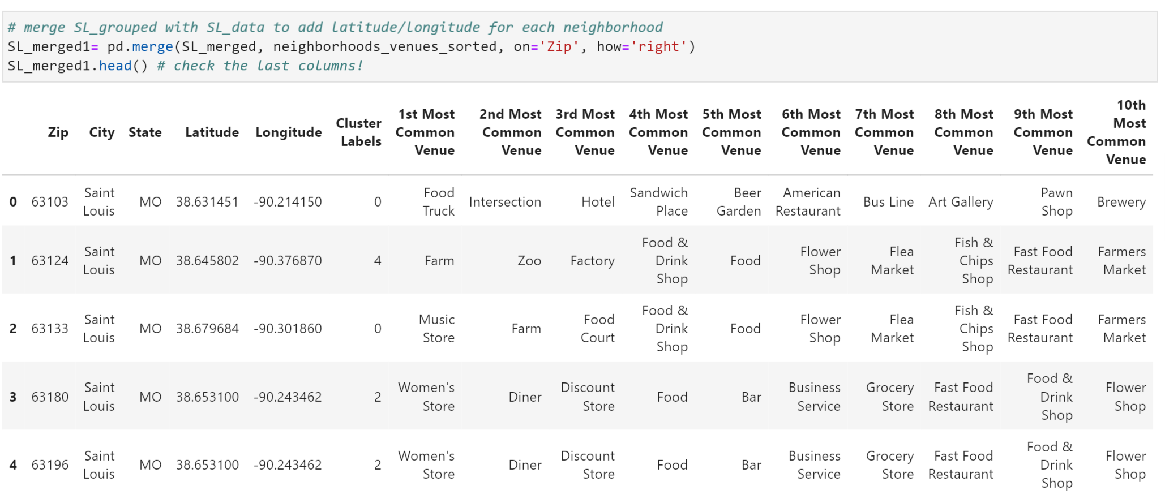

We can now visualize these clusters on the map of Saint Louis as follows:

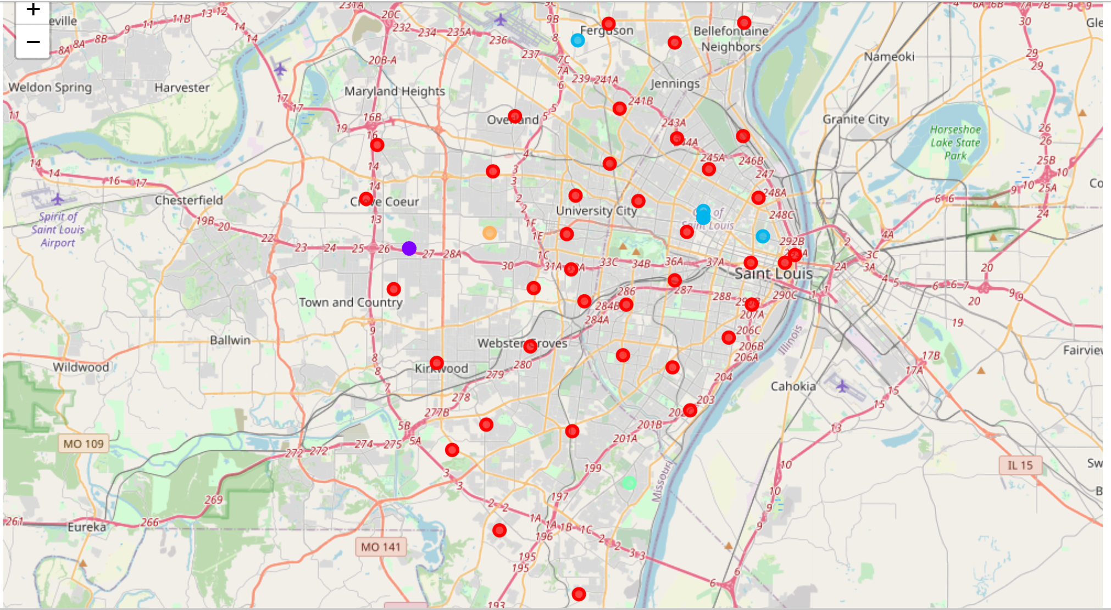

1. **Discussion**
   1. **Observations**

Let’s further look at each of the clusters:

1st Cluster:

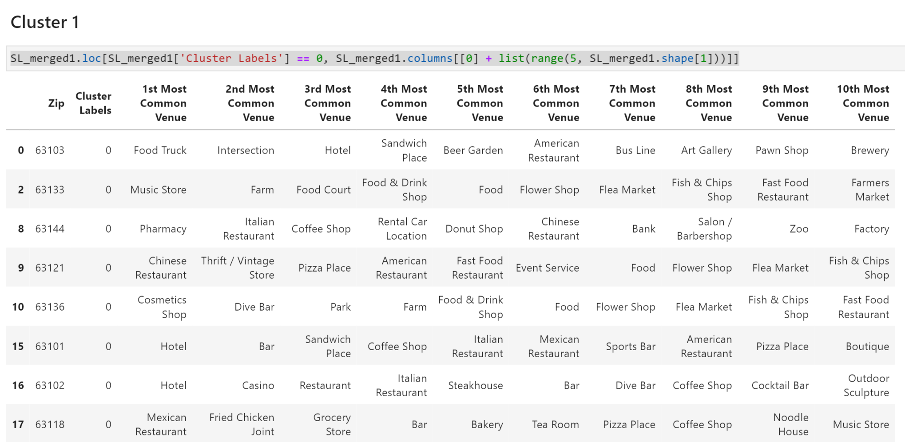

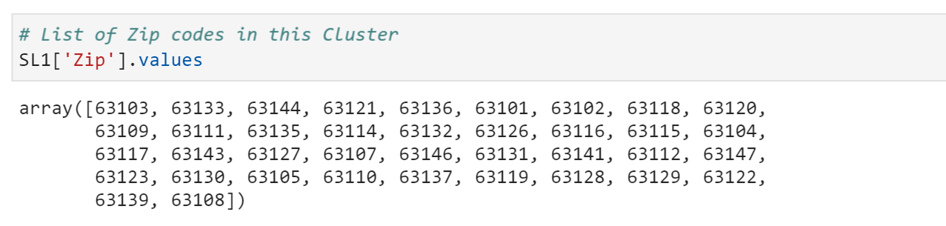

63103, 63133, 63144, 63121, 63136, 63101, 63102, 63118, 63120, 63109, 63111, 63135, 63114, 63132, 63126, 63116, 63115, 63104, 63117, 63143, 63127, 63107, 63146, 63131, 63141, 63112, 63147, 63123, 63130, 63105, 63110, 63137, 63119, 63128, 63129, 63122, 63139, 63108

In this cluster we have a total of 38 zip codes with different types of categories featuring in the 1st Most common Venue

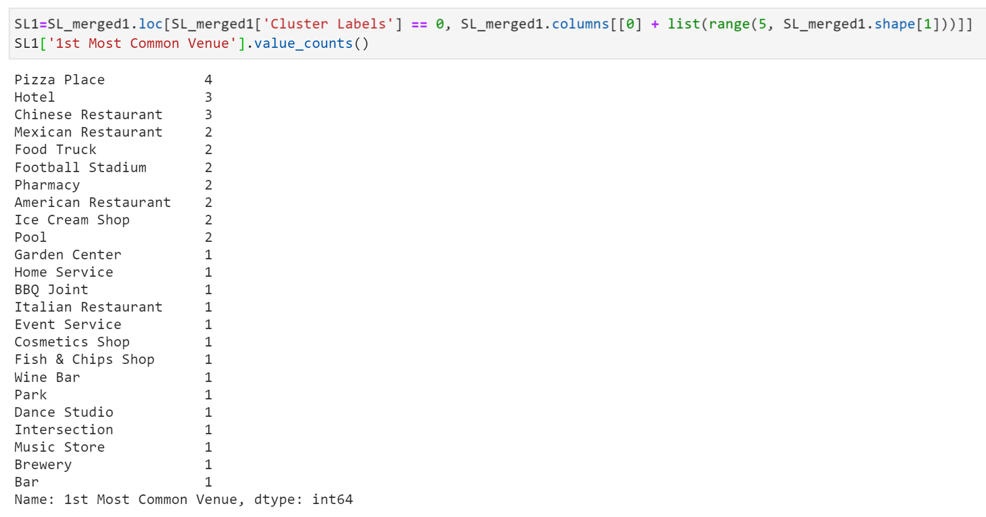

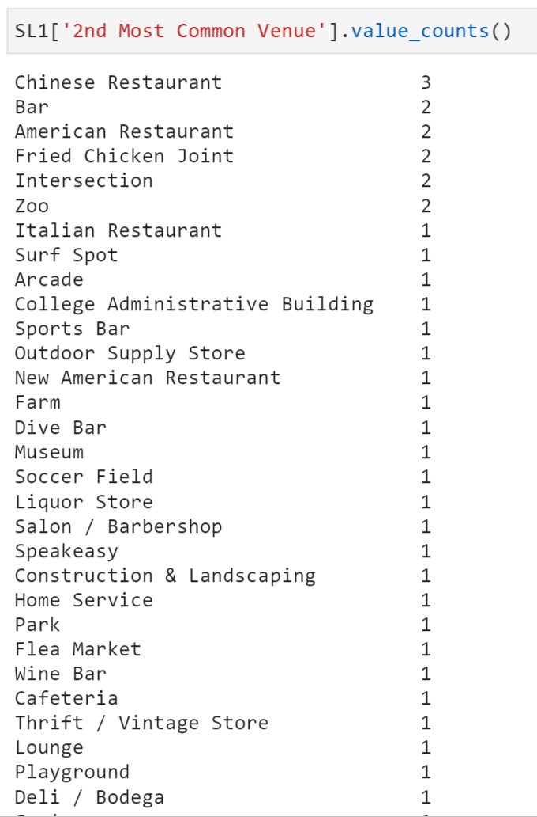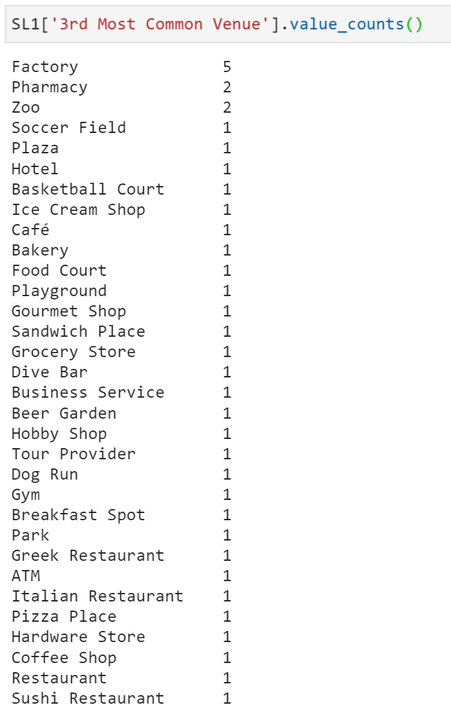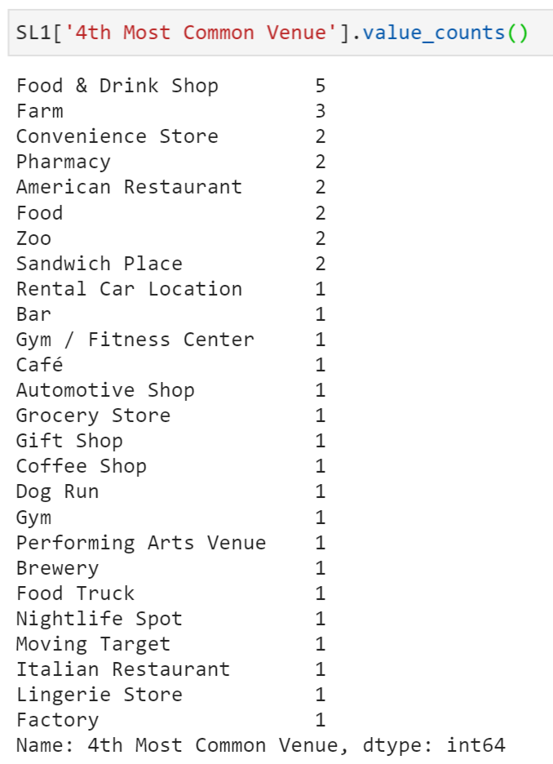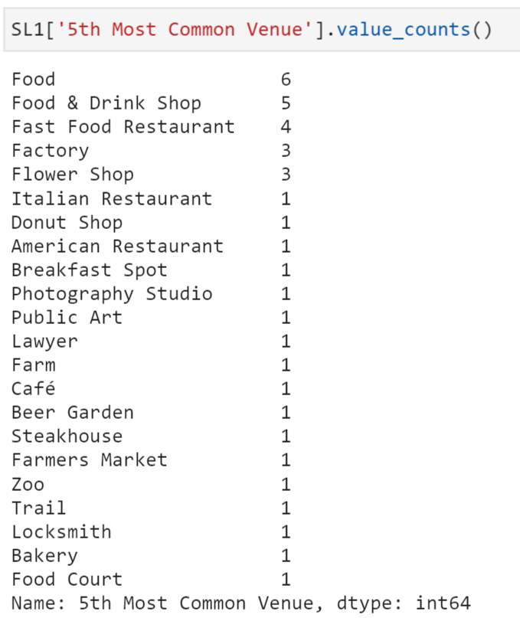

After doing further analysis, we can observe that the Top 5 most commonly venue categories for this cluster are: Pizza Place, Chinese restaurant, Factory, Food & Drink Shops, Food. There are other venues as well, but mostly this cluster of Zip codes is popular for Food joints.

2nd Cluster:

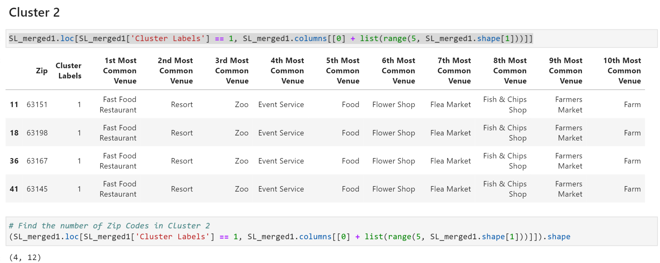

63151, 63198, 63167, 63145



This cluster has a total of 4 Zip codes with similar venue categories throughout.

3rd Cluster:

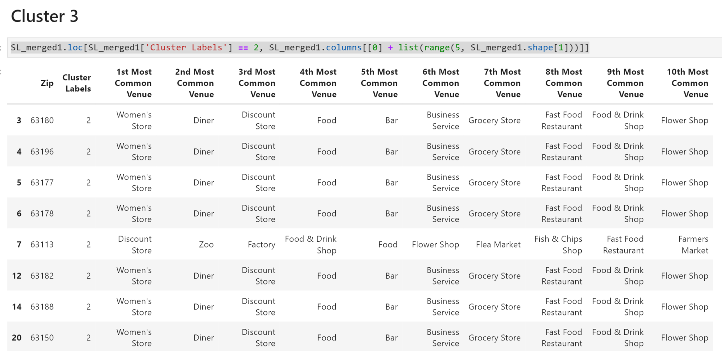



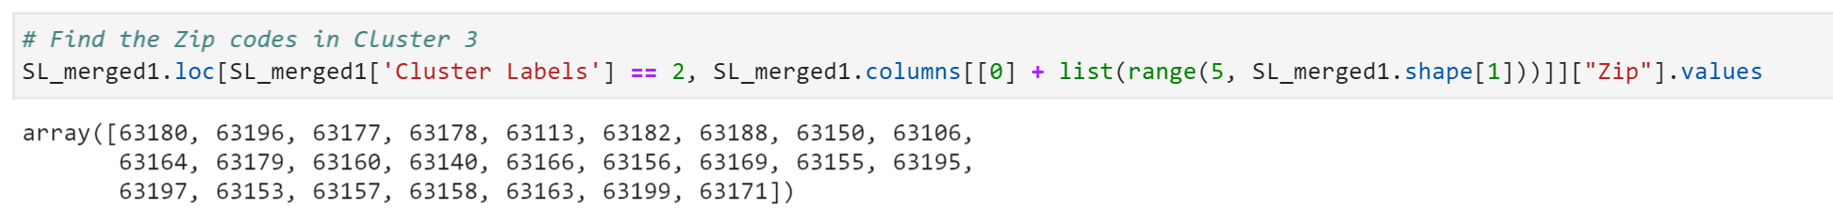

63180, 63196, 63177, 63178, 63113, 63182, 63188, 63150, 63106, 63164, 63179, 63160,63140, 63166, 63156, 63169, 63155, 63195, 63197, 63153, 63157, 63158, 63163, 63199, 63171

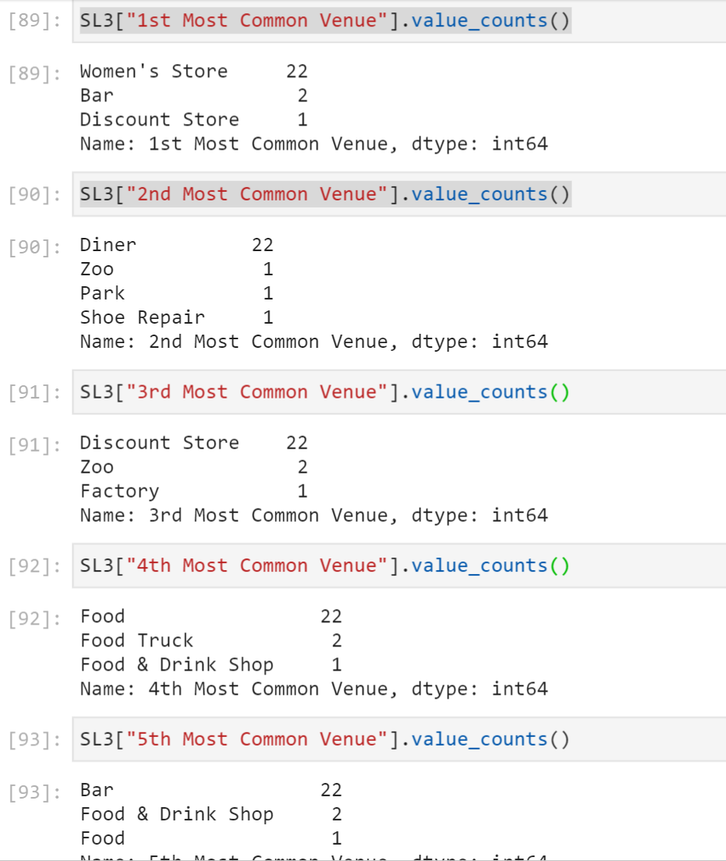

We can see that in this cluster, there are a total of 25 Zip codes. There is a consistent pattern throughout the top 10 common venues with ‘Women -Store’ as the most common, followed by ‘Diner’, ‘Discount Store’, ‘Food’ and ‘Bar’ as the top 5 venues.

4th Cluster:

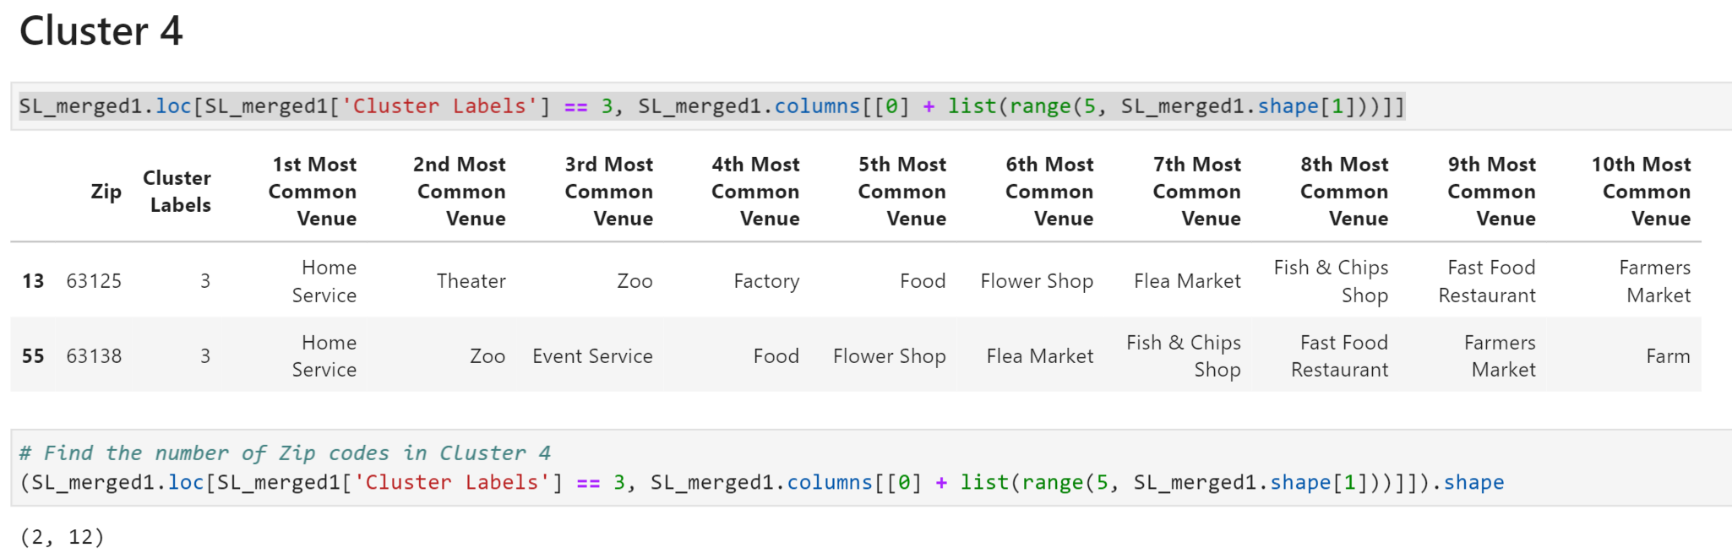

We have just 2 Zip codes in this cluster with ‘Home Service’ as most common followed by ‘Theatre’ and ‘Zoo’ as one of the top 5 venues

5th Cluster:

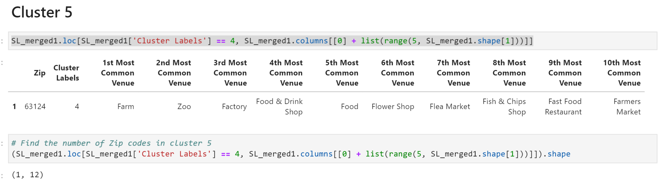

We have 1 Zip code in this cluster with ‘Farm’, ‘Zoo’ ‘Factory’, ‘Food & Drink Shop’ and ‘Food’ in the top 5 venues.

* 1. **Recommendations**

Since our problem statement was to identify which location will be best for the Entrepreneurs to open their businesses in the city of Saint Louis, we can have the certain recommendations based on our assessment of the individual clusters:

|  |  |
| --- | --- |
| Cluster Number | Zip Codes |
| Cluster 1 | 63103, 63133, 63144, 63121, 63136, 63101, 63102, 63118, 63120, 63109, 63111, 63135, 63114, 63132, 63126, 63116, 63115, 63104, 63117, 63143, 63127, 63107, 63146, 63131, 63141, 63112, 63147, 63123, 63130, 63105, 63110, 63137, 63119, 63128, 63129, 63122, 63139, 63108 |
| Cluster 2 | 63151, 63198, 63167, 63145 |
| Cluster 3 | 63180, 63196, 63177, 63178, 63113, 63182, 63188, 63150, 63106, 63164, 63179, 63160,63140, 63166, 63156, 63169, 63155, 63195, 63197, 63153, 63157, 63158, 63163, 63199, 63171 |
| Cluster 4 | 63125, 63138 |
| Cluster 5 | 63124 |

We can analyze the Most popular venue categories across different clusters to come up with the following set of Businesses that can be opened in these areas as there is already an existing demand for such businesses.

|  |  |
| --- | --- |
| **Business** | **Preferred Clusters** |
| Pizza Place | Cluster1 (Most Popular Venues) |
| Chinese Restaurant |
| Mexican Restaurant |
| American Restaurant |
| Fried Chicken Joint |
| Food & Drink Shop |
| Bar | Cluster 1 (Lesser in number but popular) |
| Cafe |
| Ice cream shop |
| Dance Studio |
| Music Store |
| Fast Food restaurant | Cluster 2 |
| Resort |
| Event Service |
| Food (General) |
| Womens’ Store | Cluster 3 |
| Diner |
| Discount Store |
| Food (General) |
| Bar |
| Home Service | Cluster 4 |
| Event Service |
| Food (General) |
| Flower Shop |
| Theatre |
| Factory | Cluster 5 |
| Food (General) |

1. **Conclusion**

In this project, I tried to analyze the different areas in the city of Saint Louis with respect to the venue categories in each. This gave us a high-level understanding of the business types and their popularity in these areas. This information can be readily used to perform some competitor analysis by entrepreneurs to find out the locations which are best suitable to start their businesses. The recommendations are provided above and can be used as a starting point to build up a business case based on existing information about these locations.